212 Software

Receiving Lockbox File
The following are quick instructions on receiving and processing Lockbox files from your bank. This will update the Owner History for the payments as well as record the deposits in each Community’s General Ledger.

To Process a lockbox files from your bank, from the TOPS main menu:

- Click Global (the last button on the main menu).
- Click Lockbox on the Global sub-menu.
- The Receive Lockbox Payments window appears.
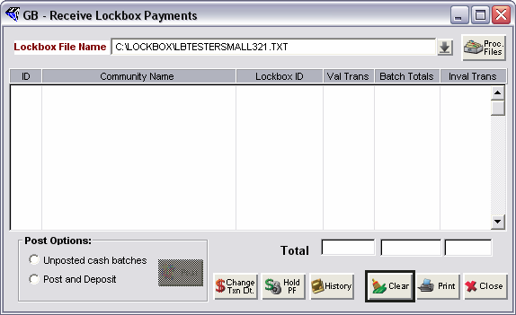

- Click the down arrow and use the browser to locate the lockbox file.
- Click the Process Files buttons.
- Use the default setting “Regular Lockbox” option as shown below:
Select Regular Lockbox
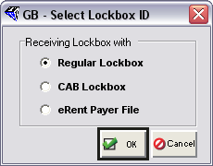

Once you click OK, the lockbox information will display in the Receive Lockbox Payment window. You may review the information on screen or in a printed report before posting.
Posting Lockbox File
Once you have received the Lockbox File from your bank and reviewed the transaction report to make sure there are no errors, you are ready to proceed to update the owners accounts for the payments. It does not matter what community you are in, whenever you do Lockbox Processing it is always done globally for all communities where there are cash receipts. TOPS 321 knows how to separate the lockbox cash receipts for each community and keep it separate from the cash receipts for any other community.

You will see the Lockbox Cash Receipts broken down by community waiting to be Posted:

Pending Lockbox Transactions
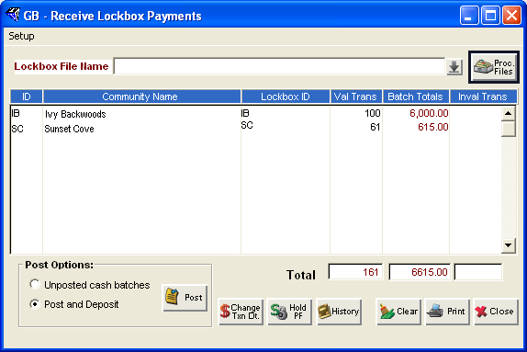

Notice these options at the bottom of the screen:
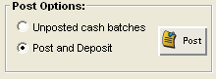
Here’s what each Posting Option does:
- Unposted Cash Batches – creates cash batches in each community where there are cash receipt transactions in the lockbox file. If you select this option, you must then go to each community to Post & Deposit the unposted cash batches. This is slower than the other post option, but it does give you the chance to see the proposed payment distribution of each payment and change it where necessary.
- Post and Deposit – this is by far the faster and more preferred method for Posting and Depositing lockbox cash receipts. It uses the default Cash Application Table for each community to determine how to distribute payments based on each owners balance due. It prints a separate deposit report for each community.

Select your Posting Option, then click on the Post button. TOPS 321 will proceed to process the lockbox cash receipts using the Post Option you selected.

This completes the instructions for using the TOPS 321 Lockbox interface programs.

