Unlimited Flex Data

User Guide

for

TOPS 2000™ and TOPS OnSite

By

TOPS Software, LLC
Clearwater, Florida

Document History |  |  | Version
 | Edition | Date | Document | Software
 | Beta  First Edition | 04-2007  06/2007 | TOPS-UFD-Beta  TOPS-UFD-AA | 3.2.1  3.2.1
Trademark | The names of actual companies and products mentioned herein may be the trademarks of their respective owners.
Copyright | Without limiting the rights under copyright, no part of this document may be reproduced, translated to another language, stored in, or introduced into a retrieval system, or transmitted in any form or by any means (electronic, mechanical photocopying, recording or otherwise), for any purpose, without the express written permission of TOPS Software, LLC.

Unless otherwise noted, the example companies, organizations, products, domain names, e-mail addresses, logos, people, places and events depicted herein are fictitious, and no association with any real company, organization, product, domain name, e-mail address, logos, person, place and event is intended or should be inferred.

Copyright © 2007 – TOPS Software, LLC, Printed in the United States of America.

Disclaimer

This user guide is provided by TOPS Software, LLC as a reference and help tool when using the TOPS Unlimited Flex Data feature. Illustrations used in this guide may display screens with modules, features, and or functions that may not be part of the basic system but available as add-ons or as plug-ins to an interface to third party products.

It is neither the intent nor purpose of TOPS Software, LLC, to provide accounting, or tax advice. For specific information regarding tax rates, deductions, and calculation speak to your company accountant or contact the appropriate Federal or State agency.

It is also assumed that the user of this guide is familiar with basic windows functionality and navigation tools. Refer questions regarding the use of Windows Explorer to your system administrator.

Contents

TOPS Unlimited Flex Data 1
Introduction 1
using Unlimited Flex Data 3
Define (Add) Flex Data fields 4
Arrange Fields 6
Arrange Field Order 7
Add New Field Categories 7
Find an Owner Record 8
Search Flex Data Values 9
Reports 10
Configure a Report 10
Add Filter 12
Print a Report 13

TOPS Unlimited Flex Data

Introduction
The TOPS Unlimited Flex Data feature enables you to add an unlimited number of custom data fields to your TOPS 2000™ or TOPS OnSite Owner databases that are unique to your business needs. You define the field types and names of your Unlimited Flex Data fields for each community.

- Convert existing Flex Data fields and data into the new system automatically.
- Define field types for better data integrity, such as text, number, date, checkboxes, etc.
- Create default/allowed values, such as selectable lists.
- Associate data with either an owner or a property (remains available after a resale.)
- Arrange custom fields in the order that you want them displayed.
- Create custom reports that include only the specific flex data fields that you wish to report on.
- Define filters to reflect specific sets of data on reports (such as an age range on a birth date field for 55 and over communities)

The TOPS Unlimited Flex Data feature allows you to store more of your owner information in TOPS 2000™ or TOPS OnSite for easy access and retrieval.

To run Unlimited Flex Data in TOPS 2000™ or TOPS OnSite, from the Main menu simply go to Owner, Maintain, select an owner, and click on the Flex Data button on the toolbar. If you are an existing TOPS user; the first time Unlimited Flex Data is accessed you are given the opportunity to convert the data from the old Flex Data format.

Note: TOPS Software, LLC recommends that you perform this step.

TOPS OnSite Owner window | 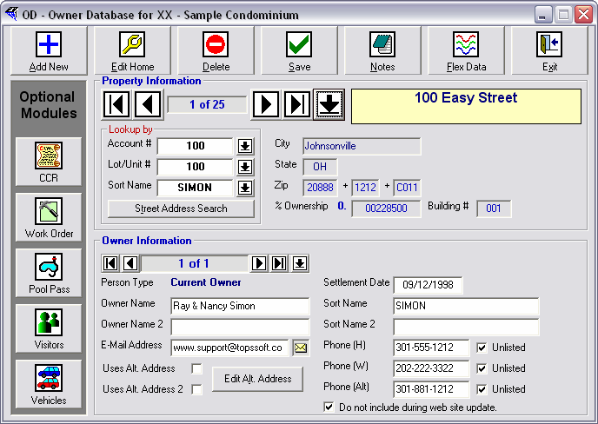
TOPS 2000™ Owner window | 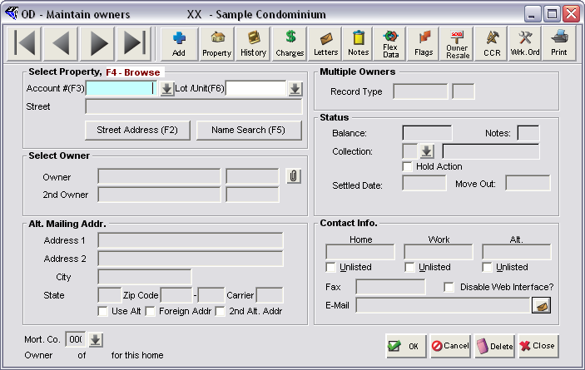

Notes: Unlimited Flex Data replaces the previous version of Flex Data. While your existing data can be converted from the old Flex Data to the Unlimited Flex Data, once converted your data cannot go backwards.
Should you choose to revert back to using the old Flex Data any changes or additions made using Unlimited Flex Data will NOT carry over. For this reason, we recommend that you activate Unlimited Flex Data for all TOPS 2000™ users that connect to the company network once you have converted the data.

using Unlimited Flex Data
The TOPS Unlimited Flex Data feature provides the option to: Define Fields, Arrange Fields, Search Flex Data, Save, Edit, Delete, Export, and print lists based on Flex Data fields you select for your output.

TOPS Unlimited Flex Data allows you to add as many Flex Data fields as you want, but first you must define the fields you want. Currently you may create five types of data fields and within some types you have options to further define how the data will display.

The types are:

Data Type | Display Types | Definition
Text  Allows you to enter any combination of characters in a field | General  Email  Web Link  Multi-Line: | Single line of text.  Contains an email field. Displays a button that allows you to email to the email address in that field.  Contains a URL. Display a button that allows you to go to that URL.  Multiple line box of text.
Number  Uses a text box, but will only accept numbers. | Whole Number  Decimal  Currency | Whole numbers only - no decimal points.  Allows decimal points.  Restricts the display to dollar/cents amounts.
Date  Displays a date | No display options | Displays date in MM/dd/yyyy format.
Checkbox | No display options | Simple on/off checkbox.
List | No display options | A pull-down list.

Define (Add) Flex Data fields
To access Unlimited Flex Data start TOPS 2000™ and login. Select the community for which you will be adding fields.

From the TOPS 2000™ main menu:

- Click the Owner button.
- The sub-menu options appear.
- Select Maintain.
- The Maintain Owners window appears.

- Click the Flex Data button on the toolbar.
- You will receive the following Warning.

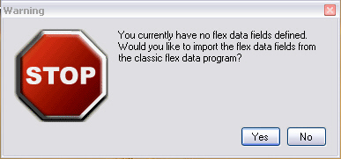

If you are an existing TOPS 2000™ user this will import the data fields that are already setup in the previous version of the Flex Data feature, as well as the data. The program will import them as simple text fields. Once the fields have been imported, a flag is set to NOT allow the import option again, preventing the accidental overwriting of your data.

- Click Yes to import now.
- The Owner Flex Data window appears.

Owner Flex Data window:  Displaying two imported Flex fields. | 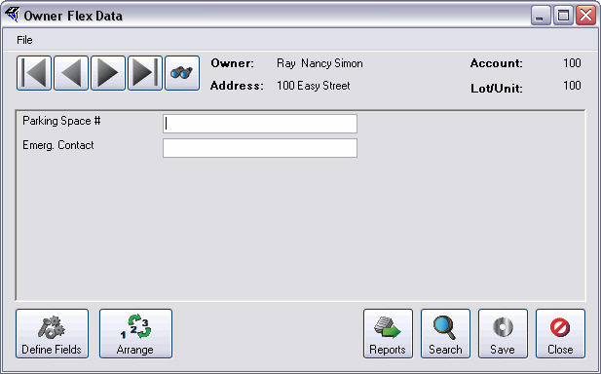

- Click the Define Fields button located at the bottom left of the window.
- The Define Fields window appears.

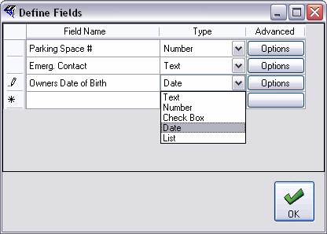

- Place your cursor in an empty Field Name field and type the name of your new Flex Data field.
- Click the Type drop down arrow to display options and select one.
- Click OK to save your settings
or
Click the Advanced Options button to display additional formatting options.

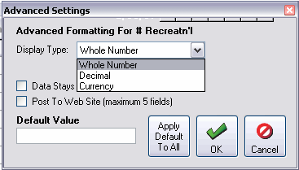

The additional options are:

- Post To Web – when selected indicates that the field will be uploaded to the community web site if they have one. There is a limit of 5 fields that can be uploaded. If 5 fields are already checked for Post To Web, the option will be grayed out. You will need to disable the Post To Web option for another field in order to have the option again.
- Data Stays With Unit On Resale - when a resale occurs, it will delete all values in all fields EXCEPT those that have this checked. Therefore, values in a field with this option checked will NOT change on resale.
- Default Value: will set all owner records for this field to have the same value that is entered. When you click OK on the Advanced Options screen, you will then be prompted and asked if you wish to apply the default values right now.

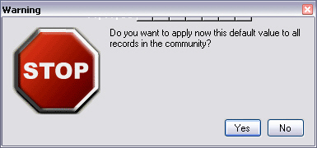

Important: If you click Yes, it will immediately apply the data entered into the field overwriting any existing values for that field. Click No if the value in this field will vary from homeowner to homeowner.

- Click OK to save selections.
- You are returned to the Owner Flex Data window.

Owner Flex Data window | 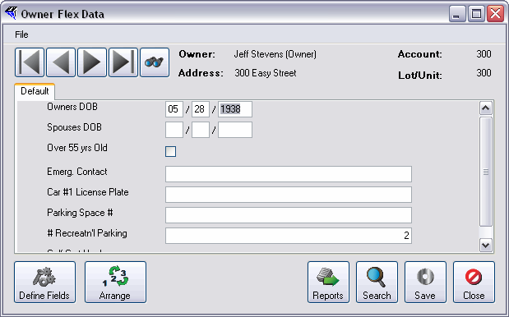

Arrange Fields
When adding fields you will eventually exceed the visible display area. Notice in the example above that the group box now includes a scroll bar that allows you to scroll up and down through your list of fields.
Unlimited Flex Data allows you to arrange the order in which your Flex Data fields appear, and to categorize your fields, displaying them in separate tabs that you define.

All newly defined Flex fields will appear in the Default tab.

Arrange Field Order
To change the order in which the fields are displayed in the Default tab:

- Click the Arrange button.
- The Arrange Fields window appears.

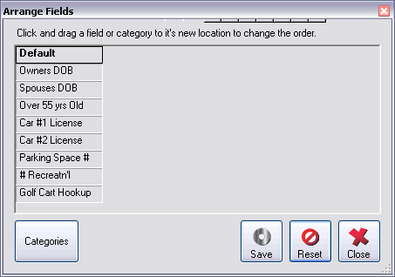

- To move a field, Click and hold the selected field name in the list.
- Drag the item to the desired position in the list and Drop by releasing the mouse button.

Add New Field Categories
To create new tabs to categorize fields, from the Arrange Fields window:
- Click the categories button.
- The Categories window appears.
- Click the Add button.
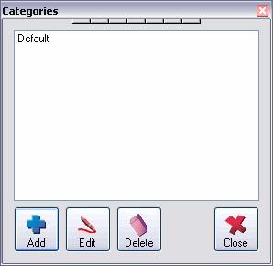
- The Category Name window appears.

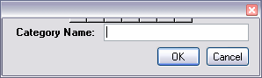

- Enter a Category Name.
- Click OK.
- You are returned to the Arrange Fields window.
- Click to Grab fields from the Default list, then Drag and Drop the field under the desired category heading.

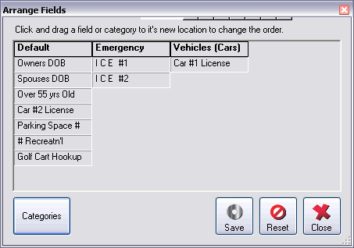

Note: You may also rearrange the order in which the tabs appear by dragging and dropping the tab header to the desired position.

- Click the Save button when you have finished arranging the fields into the desired categories.
or
Click the Reset button to restore the last saved field arrangement.
- Click the Close button to return to the Owner Flex Data widow.

Owner Flex Data window:  New Category tabs | 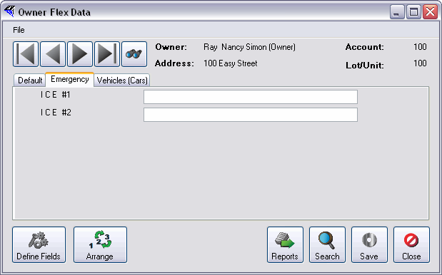

Note the two new tabs, Emergency and Vehicles in the example above. Now you are ready to begin entering your data.

Find an Owner Record
Use the navigation arrows to move through the owner records or Click the Find button (binoculars icon) to the right of search arrows to open the Owner Search window.

- Select a Search By option. The options are: Owner Name, Street Address, Account # or Lot/Unit #.

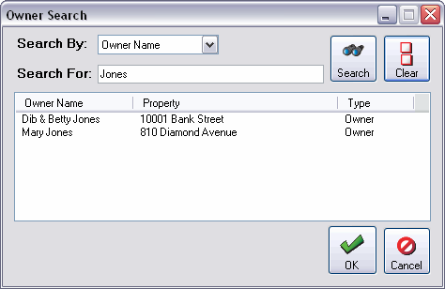

- Enter the name or number you wish to find.
- Click the Search button.
- A list of records appears.
- Click to select the record.
- Click OK.
- You are returned to the Owner Flex Data window.
- Enter the new data and click Save to save the data in the database.

If you try to close the Owner Flex Data without saving your data, a dialog box will appear prompting you to save before closing.

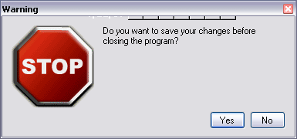

Click Yes to save, Click No to discard the changes and simply quit, or click the red X at the top-right of the prompt to cancel exiting the program.

Search Flex Data Values
Unlimited Flex Data enables you to search for a particular value that is stored in a Flex Data field in the owner database. For example, the car parked in a homeowner’s space does not match the description on record. License Plate numbers are a Flex Data field in your system. Search to see if the particular license plate number is in the owner database.

To access the Search feature from the Owner Flex Data window:
- Click the Search button or Click File and Select Search Values.

Owner Flex Data window:  Search Button | 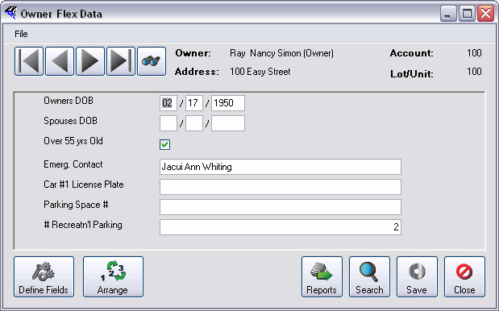

- The Search window appears.

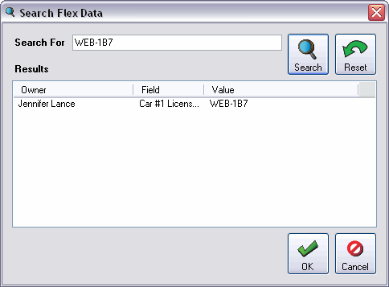

- Enter the value to look for, Click Search.
- The results will list the owner that the value is associated with, the field in which the value appears, and the actual value.
- Double-click the item to go to the owner's record.

Reports
The Reports feature allows you to configure reports using the data contained in your Flex Data fields. Depending on the data field type you may also include statements that will enable you to drill down and extract only those records that match the criterion that you have setup for the report.

Configure a Report
From the TOPS 2000™ main menu:

- Click the Owner button.
- The Sub-menu options appear.
- Select Maintain.
- The Maintain Owners window appears.

- Click the Flex Data button located on the toolbar.
- The Owner Flex Data window appears.

Owner Flex Data window:  Displaying all Flex fields. | 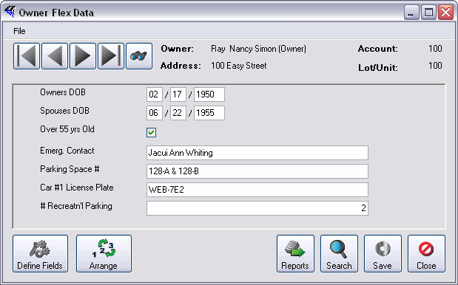

- Click the Reports button located at the bottom right of the window.
- The Flex Data Reports window appears.

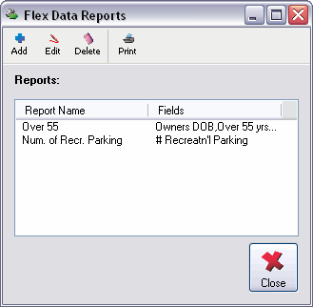

- Click the Add button.
- The Configure Report window appears.

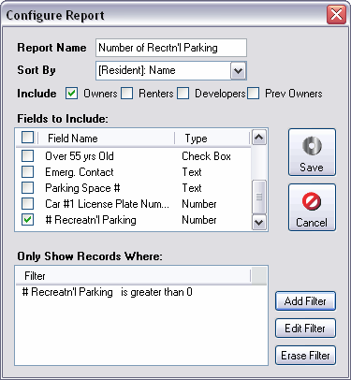

- Enter a name for your new report in the Report Name field.
- Click the Sort By dropdown arrow and select an option.
- Click a checkbox beside each Resident/Owner type you wish included in the report.
- Click the checkbox to the left of each field you wish to include in the report.
- Click Save or proceed to Step 14 to add filters that will define very specific information contained in the Flex Data fields.

Add Filter
You may drill down to isolate specific values in the Flex Data fields. The Report output will only display the records that match all of the criteria you define using these filters.

- Click the Add Filter button.

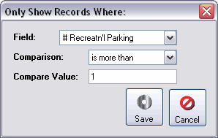

- Click the Field dropdown arrow.
- Select the field that contains the date to be filtered.
- Click the Comparison dropdown arrow and select the filter criteria.
- Enter the value the comparison will be based on.

The available comparison criteria will depend on the Field type for the selected Field. For example if you select a field that is a check box, which has a Yes / No value the criteria will be limited to either “Equal to” or “Not Equal to”.

- Click Save.
- You are returned to Flex Data Reports window.

Print a Report
To print a report from the Flex Data Reports window:

- Click Report Name in the Reports list to highlight.
- Click the Print button.

- The Print Options window appears.
- Click the radio button to the left of a Print To option. The Print to options are:
Printer, Screen, PDF Export, Excel Export, E-mail and Community Web Site.
- The Layout default setting is Portrait.

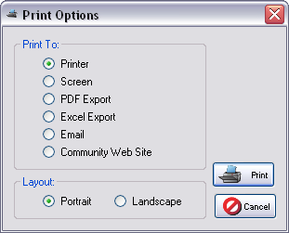

- Click the Print button to create the report output.
- Click Cancel to end the print command.

Report Example | 